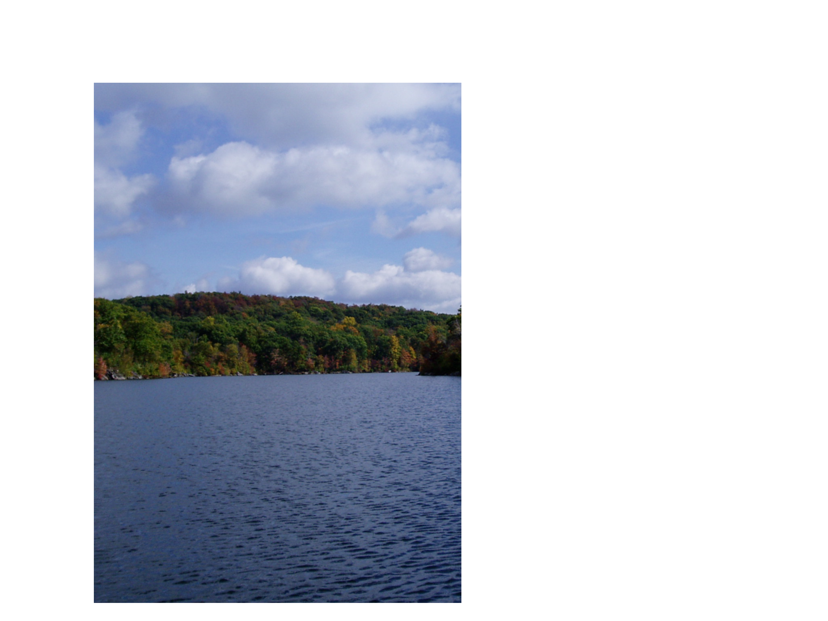


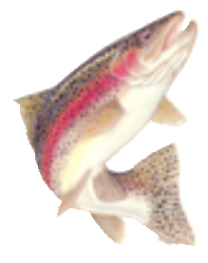

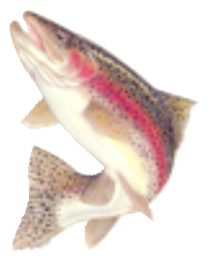

& G Levy)

lus entry fee

Mt Maunganui Sport Fishing Club

Presents

2026 All Rotorua Lakes & Rivers

Trout Tournament

22nd – 24th May 2026

Area: All Rotorua Lakes & Rivers (excluding Lake Aniwhenua)

Eligibility: MMSFC members, day members or financial members of a club affiliated to NZSFC Entry:
$30 per adult, $15 per junior. (Includes F & G Levy)
Non-members $10 for day membership plus entry fee

Entries Close: 7pm Thursday 21st May 2025

Prizes: 1st heaviest – Boat section

1st heaviest – Land based section

2nd – 5th heaviest overall

10 Mystery fish weight prizes

1st, 2nd, 3rd Junior section

Best Condition factor Male angler

Best Condition factor Female angler

Worst Condition Factor

Overall average weight

One prize per fish only

X2 Lucky Draw Spot Prize (Saturday weigh in only)

Weigh In: Saturday - 12pm to 1pm at Otaramarae boat ramp, Rotoiti.

Sunday – 4pm to 5pm at Mt Sport Fishing Club (MOSC clubrooms, Salisbury Ave)

Prizegiving: Sunday 6:30pm at MOSC

Convenors: Dean Tiriana 0276054205 Blake Swanepoel 0225730908

All skippers are responsible for the safety of their vessel and crew at all times during the tournament.

Supported by these people and business.
Kilwell Sports – Heaviest Fish, Hamills - Mystery weight prizes,
Stump Boss – Junior sections, Les Harrison Transport – Best and Worst condition factor (fish or angler)
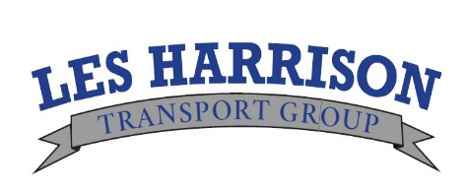


Area: All Rotorua Lakes & Rivers (excluding Lake Aniwhenua)
Eligibility: MMSFC members, day members or financial members of a club affiliated to NZSFC Entry: $30 per adult, $15 per junior. (Includes F & G Levy)
Non-members $10 for day membership plus entry fee
Entries Close: 7pm Thursday 21st May 2025

Prizes: 1st heaviest – Boat section
1st heaviest – Land based section
2nd – 5th heaviest overall
10 Mystery Fish Prizes
1st, 2nd, 3rd Junior section
Best Condition factor Male angler
Best Condition factor Female angler
Worst Condition Factor
Overall average weight
One prize per fish only
X2 Lucky Draw Spot Prize (Saturday weigh in only)
All anglers must have a current region license
and adhere to the rules thereon
https://fishandgame.org.nz/eastern/freshwater-fishing-in-new-zealand/fishing-regulations/

We must have your license number
(No license number = no fish weighed)

Maximum of 4 trout per person per weigh in
All fish must exceed 45cm in length
One prize per fish
Fishing times
Start: Friday 22nd May 12 noon
Stop: Sunday 24th May 3pm
Weigh In: Saturday 23rd May- 12pm to 1pm at Otaramarae boat ramp, Rotoiti.
Sunday 24th May -4pm to 5pm at Mt Sport Fishing Club (MOSC, Salisbury Ave). Prizegiving: Sunday 24th May 6:30pm at MOSC Clubrooms
Convenors: Dean Tiriana 0276054205 or Blake Swanepoel 0225730908
All skippers are responsible for the safety of their vessel and crew at all times during the tournament.
You can pay by Direct Credit to MMSFC bank account 03-0374-0154303-00

 | Name |  | F&G License # | Membership  # | Day Member  $10 | Junior  $15 | Adult  $30
1
2
3
4
5
Team Captain: |  |  |  |  | Total: $
Address:
Phone: Home Mobile:
Call Sign: |  | Boat Name:

